**Lab#1: Introduction to Logisim**

LogiSim is a simulator that is used for designing and testing digital logic circuits such as logic gates, combinational and sequential logic. LogiSim is one the most popular free digital design simulators. Download logicSim from **www.cburch.com/logisim**/ and install it on your computer. When you run LogiSim it will display the following window. The initial screen consist of Menu Bar, Tool Bar, Explore Pane , Attribute table and design canvas. For more information for LogicSim refer to the LogiSim tutorial, which can be found on **www.cburch.com/logisim**/

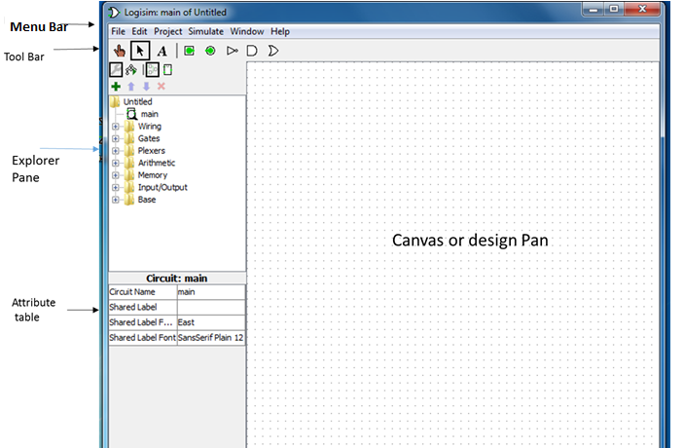

A. **Manu Bar**: contains File, Edit, Simulation, Windows and Help

B. **Tool Bar**: contains following information

1. **Poke Tool**  which is used to change the state of a device, by clicking poke tool user can change input device values.

2. **Select Tool** which allows a user to select item(s) on the canvas.

2. **Input Pin**  to generate binary input

3. **Output Pin**  to display one-bit binary

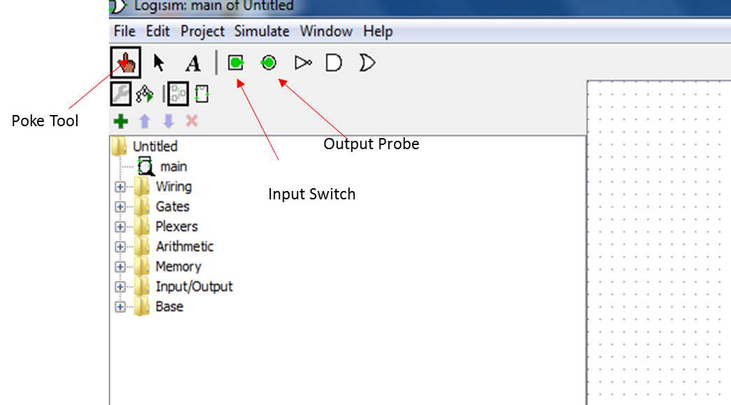

C. **Explore Pane:** Displays a list of circuits contained in your file. By double clicking on the circuit will cause that circuit to display on the canvas. The circuit you are displaying on the canvas at will have an magnifying glass in the Explorer Pane.

Also shows the categories of components. When you click on a plus next to the category it will display the list of components in that category. For example, by clicking on Gates it will display list of the gates in this category.

Building the circuit:

1. Click on the + next to Gates so that the list expands
2. Click on the AND Gate
3. Set the Number of Inputs to 2

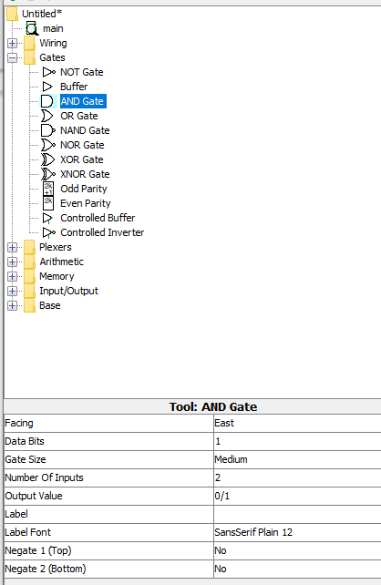

1. Move your mouse onto the canvas, you should see an outline of the AND Gate, and click on the canvas. This will place the 2 input AND Gate onto you canvas.
2. From the Tool Bar, click on an Input Pin, 
3. Move the mouse onto the canvas, you should see an outline of the Input Pin, and click on the canvas. This will place a single Input Pin onto your canvas.
4. Change the label of the Input Pin to X. You’ll find the label property under the Attributes.
5. From the Tool Bar, click on an Input Pin, 
6. Move the mouse onto the canvas, you should see an outline of the Input Pin, and click on the canvas. This will place a second single Input Pin onto your canvas.
7. Change the label of the Input Pin to Y. You’ll find the label property under the Attributes.
8. Move your mouse over the green dot on one of the Input Pins. Note that you’ll see a green circle appear.
9. Click and hold the mouse. Now drag the mouse to create a wire. If you let up the mouse the wire will be on the canvas. Repeat the creation of wires until the first Input Pin is wired to the first input of the AND Gate.
10. Repeat the process and wire the second Input Pin to the second input of the AND Gate.
11. From the Tool Bar, click on an Output Pin, 
12. Move the mouse onto the canvas, you should see an outline of the Output Pin, and click on the canvas. This will place an Output Pin onto your canvas.
13. Change the Label of the Output Pin to F.
14. Move your mouse to the green dot for the output of the AND Gate. Note that you’ll see a green circle appear.
15. Click and hold the mouse. Now drag the mouse to create a wire. If you let up the mouse the wire will be on the canvas. Repeat the creation of wires until the output of the AND Gate is wired to the Output Pin.

**Example:**

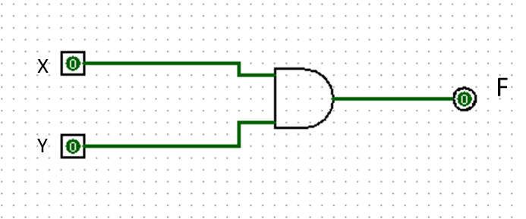

**Simulating the Circuit:**

1. Click Poke Probe
2. Then click on and Input Pin to change the input from 0 to 1 and note the Output Pin.
3. Continue to click on the Input Pins until you test all possible inputs.
4. Use the results to complete the truth table for the 2 input AND Gate:

|  |  |  |
| --- | --- | --- |
| X | Y | F |
| 0 | 0 | 0 |
| 0 | 1 | 0 |
| 1 | 0 | 0 |
| 1 | 1 | 0 |

From the menu select File and Save. Save the file as “Labs 1 and 2.circ”